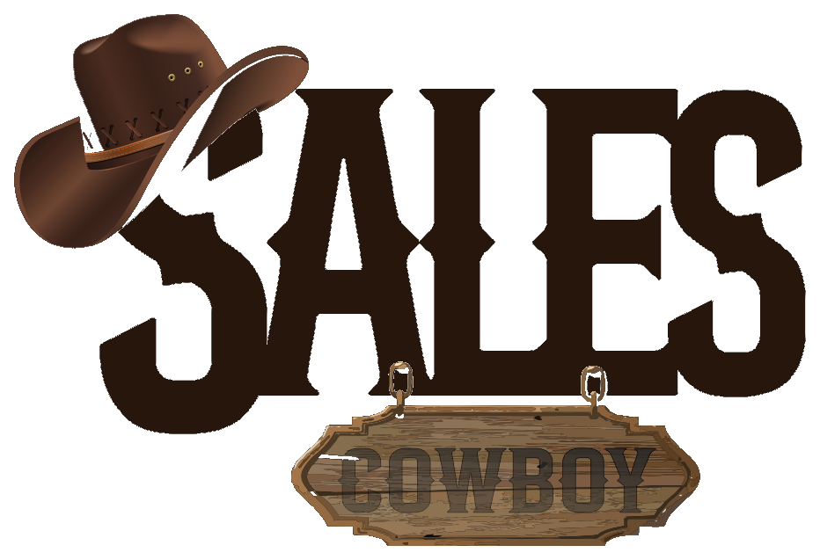 SALES COWBOY  Marketing Solutions • Hospitality Growth & Revenue Engineering  Red Brick House, Peace Land Estate, Ogombo, Ajah, Lagos, Nigeria  hello@salescowboy.com.ng • +234 810 493 3232 • salescowboy.com.ng | [HOSPITALITY REVENUE AUDIT]  REF: AUD-SYM-2026-003  DATE: November 05, 2026  STATUS: CONFIDENTIAL
――――――――――――――――――――――――――――――――――――――――――――――――――――――――――
DIGITAL SEARCH VISIBILITY & REVENUE AUDIT
Executive Growth Diagnostic, Digital Leakage Assessment & 5-Pillar Turnkey Turnaround Strategy
PREPARED FOR:  The Executive Board & General Management  Sym Hotels and Lodge  Princess Adeja Road, Akaajime, Gboko, Benue State | PREPARED BY:  Sales Cowboy Marketing Solutions  Hospitality Revenue Engineering Group  Ajah, Lagos • salescowboy.com.ng  Contact: +234 810 493 3232

DIGITAL HEALTH SCORE  12 / 100  VIRTUALLY INVISIBLE | CRITICAL FINDING: COMPLETE REVENUE & SEARCH BLIND SPOT  Sym Hotels and Lodge operates in Gboko—the bustling commercial and cultural capital of Benue State—yet has virtually ZERO searchable footprint across Google Search, Google Maps, and Local Pack. Aside from an unoptimized Facebook profile and a third-party Hotels.ng listing, corporate travelers, wedding entourages, and diaspora visitors cannot discover or book your rooms directly. Every week, dozens of direct bookings are surrendered to nearby competitors and third-party OTAs.

0  Google Business Profile  Not verified on Google Maps or local searches | 0  Direct Website  Zero owned direct booking or online payment | 0%  WhatsApp Booking Bot  Manual replies only; guest drop-off exceeds 80% | 15-20%  OTA Commission Loss  Paid to Hotels.ng per booked room night

1. THE GUEST BOOKING LEAK FUNNEL (WHERE YOU LOSE REVENUE)
Modern travelers, civil servants, wedding guests, and NGO workers do not arrive in Gboko blindly. They query Google Search and WhatsApp. Here is what currently happens to 100 potential guests searching for accommodation:
STAGE | GUEST BEHAVIOR | SYM HOTELS STATUS | REVENUE IMPACT
1. Google Search | Traveler searches 'Best hotels in Gboko' or 'Princess Adeja Rd lodge' | NO verified Google Maps card or GBP exists. Sym is invisible in the Local 3-Pack. | 70% LEAK  Guest chooses listed competitors immediately
2. Social Discovery | Visitor searches Facebook for amenities, photos, restaurant & bar | Outdated Facebook page with no booking link or live room availability rates. | 15% LEAK  Guest doubts facility legitimacy
3. Direct Inquiry | Guest attempts to message on WhatsApp or call front desk | No automated concierge. Delayed or uncoordinated response during late hours. | 10% LEAK  Slow response kills high-intent booking
4. OTA Booking | Guest finally finds Sym on Hotels.ng intermediary directory | Hotels.ng captures the transaction and deducts 15% to 20% commission on the room night. | 5% SURVIVE  Sym forfeits ~₦3,000 to ₦6,000 per room night

● THE GBOKO MARKET REALITY: THE CAPITAL OF TIV NATION
Gboko is not an average rural town—it is the paramount seat of the Tor Tiv, the epicentre of Tivland cultural congresses, agricultural produce distribution, and federal/state institutional delegations. During weekends, festivals, and weddings, hotel occupancy spikes. Without an authoritative Google Business Profile and instant online booking, Sym Hotels leaves hundreds of thousands in high-margin weekend bookings on the table.

2. LOCAL SEARCH & COMPETITOR VISIBILITY MATRIX (GBOKO)
CRITICAL DIGITAL ASSET | SYM HOTELS | TOP GBOKO RIVALS | BENCHMARK | OPPORTUNITY GAP
Google Business Profile (Maps) | MISSING / UNVERIFIED | Active (15-40 reviews) | Top 3 Local Pack Rank | Easy win: Claim #1 spot on Princess Adeja Rd
Direct Booking Engine | NONE (Hotels.ng only) | Phone calls / OTA only | Mobile Instant Booking | Pioneer zero-commission booking in Gboko
24/7 WhatsApp AI Reservation | NONE (Manual only) | None (Manual WhatsApp) | Sub-60s automated booking | Capture after-hours late traveler arrivals
Guest Review Architecture | 0 Google Reviews | 10-25 mixed ratings | 4.5+ Stars / 50+ Ratings | Deploy Smart Gateway QR at front desk
Transit & Physical Wayfinding | Basic Gate Board | Standard Signage | High-Visibility Billboards | Capture road transit from Makurdi & Aliade

3. THE 5-PILLAR TURNKEY HOSPITALITY GROWTH SYSTEM
★ PILLAR 1: DIRECT HIGH-CONVERTING BOOKING ENGINE
A bespoke, blazing-fast direct booking website. Highlights rooms, executive suites, VIP lounge, bar, conference spaces, and generator power guarantee. Direct Paystack / Monnify integration for instant card & bank transfer reservations without 20% OTA cuts.

★ PILLAR 2: 24/7 AI-POWERED WHATSAPP CONCIERGE
Automated booking bot handling guest inquiries, room photo previews, pricing, check-in instructions, and payment confirmations in under 15 seconds. Works 24 hours a day, capturing late arrivals from Gboko-Makurdi expressway.

★ PILLAR 3: GOOGLE LOCAL 3-PACK DOMINANCE & REVIEW FLYWHEEL
Establish, verify, and aggressively optimize Sym Hotels and Lodge on Google Business Profile. Deploy acrylic Smart Gateway QR stands at front-desk to scale real 5-star Google guest ratings from 0 to 50+ verified reviews within 60 days.

★ PILLAR 4: SOCIAL MEDIA ENGINE & BRAND REPUTATION
Complete visual transformation across Facebook & Instagram. High-resolution photography of guest rooms, food/drinks, VIP security, clean sanitation, and weekly targeted local ad campaigns capturing Gboko event planners and visitors.

★ PILLAR 5: TRANSIT & STRATEGIC WAYFINDING BILLBOARDS
Design and placement strategy for clear directional transit signage at critical junctions (Akaajime junction, Princess Adeja entrance, and Gboko express corridor) ensuring incoming motorists and travelers locate Sym Hotels with zero friction.

PROJECTED REVENUE ACCELERATION
+₦1,200,000 – ₦3,000,000
Estimated incremental monthly direct room revenue captured through Google 3-Pack rank, 24/7 WhatsApp reservations, and 0% OTA commission savings within 90 days of system launch.
4. 4-WEEK ROLLOUT SCHEDULE & NEXT STEPS
TIMELINE | CORE MILESTONE | DELIVERABLES
Week 1 | Local Search & GBP Setup | Claim & verify GBP, professional photography brief, geo-tagging, Local 3-Pack profile completion.
Week 2 | Direct Website & Engine | Deploy responsive web booking engine, room showcases, direct payment gateway integration.
Week 3 | WhatsApp Concierge & QR | Configure 24/7 WhatsApp bot, deploy acrylic Smart Gateway QR review stands at front desk.
Week 4 | Transit Signage & Ads | Install directional road transit boards, activate hyper-targeted social media campaigns, staff training.

Sales Cowboy Marketing Solutions is prepared to deploy this complete growth engine for Sym Hotels and Lodge immediately. Let us turn your digital presence from invisible to the #1 hospitality choice in Gboko.
Respectfully submitted,
SALES COWBOY MARKETING SOLUTIONS
Hospitality Growth & Revenue Engineering Division
Red Brick House, Peace Land Estate, Ogombo, Ajah, Lagos, Nigeria
Direct: +234 810 493 3232 • Email: hello@salescowboy.com.ng

